Welcome!
Date
Name
Spouse
Address
City
State Zip _________
Email

Please Contact By
❑ Card  Phone  Visit

Telephone Best Time to Call
Home ______________
Work ______________

Guest: First Time Second Time
Are you a church member: yes no
Church
City, State

Circle Appropriate Age/Grade Group(s)
Preschool: Ages: B-1 2-3 4-5
Children: Grades: K 1 2 3 4 5 6
Youth: Grades: 7 8 9 10 11 12
Adults: Ages:18-29 30s 40s 50s 60s+

How did you learn about our church?
Newspaper Friend Yellow Pages Mail
Other

I am a guest of:

New in the Community? Yes No
Names & ages of children at home

Weekly Service & Activity Schedule

October 4, 2015

9:45 a.m. Sunday School
11:00 a.m. Worship Service
6:00 p.m. Evening Worship

Week of October 4, 2015
Wednesday 6:30 pm Meal/ Adult Bible Study
Thursday 10:00 am Adult Fellowship

Upcoming Events

October
11…………………………………….………Business Meeting
18……...Independence Baptist Assoc. Mtg – Chappel Hill
22…………………………….……………….Adult Fellowship
25………………………..…………High Attendance Sunday


Ladies
Join us today after the worship service for a bridal shower honoring Rachel Edwards

The Cookbook Committee needs your recipes!!
In order to have the books available for Christmas, they need to get busy, so grab some blank recipe forms in the foyer of the Sanctuary and give us your best recipes. Recipe deadline is Oct 18.

Contact Evelyn Robinson if you have any questions.



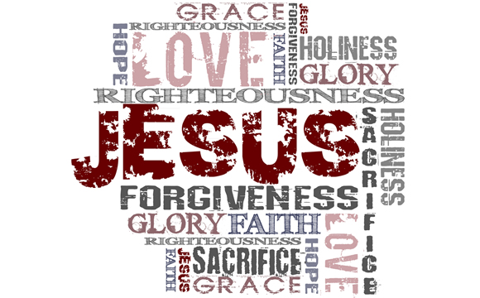

Knobbs Springs Baptist Church

October 4, 2015

Church Information:

KnobbsSpringsBC.com KnobbsSpringsBaptist@gmail.com

1662 CR 305, McDade, Texas 78650 512-273-2743

David Atwood, Pastor Cell 512-470-5098
Home 512-856-2819
Patti Radford, Office Manager Cell 512-968-7821

